**REPORT SUBMISSION SHEET**

**Please follow these instructions carefully**

Add your URN and report subject and upload this page as the first page of your report submission to SurreyLearn to the Report folder in the Assignments tab by

**17:00 on Thursday March 16th**

Please upload three copies of the report (each containing this cover sheet). The file name of the **Word** documents you upload must be your URN, followed by a space, a dash and a space, then “report” plus the letter A, B or C. **It is very important that you follow these instructions exactly**. This is to ensure confidentiality at all stages of the peer review process.

Thus if your URN is 9008708 the title of your three documents will therefore be

**“9008708 - reportA.docx”, “9008708 - reportB.docx” and “9008708 - reportC.docx”**

Do **not put your name** anywhere on your report, either in the body of the text, the title or any headers or footers.

**Do not upload the document as a pdf or in any other format than Word.**

You need to delete any references to authorship in order to maintain anonymity.  In your Word document click on **File**, in the **Info** page which comes up click on **Check for Issues** and then **Inspect Document**.  On the **Document Inspector** dialog box click **Inspect**.  Word will check the document and a box will come up headed **Document Properties and Personal Information**. Click on **Remove All** and then click **Reinspect**.  Continue to click on any other **Remove All** buttons which appear and once more click **Reinspect.** Then click on **Save.**

These steps will ensure that your report can be given anonymously to the three peer reviewers and that every document is uniquely identified in the marking process. You will receive feedback, anonymously from each of the three reviewers.

6405493

**URN**

**REPORT SUBJECT**

General Election – The advantages and disadvantages of the ‘First Past the Post’ voting system

***Late Submission***

*If you do not submit your report by the deadline specified and there are no confirmed extenuating circumstances,* ***the mark awarded will be reduced by 10 percentage points for each 24 hour period after the deadline, up to and including the third day after the submission*** *(30 percentage points).  Therefore, if the mark were 80%, but the report was submitted 30 minutes past the deadline, you would be awarded a mark reduced by 10% to 70%. The mark recorded for a* ***report submitted******after 10am on Thursday 21st April is zero****.  The same penalties will apply to the peer review submissions. If you have not submitted a report you will not participate in the peer review process and will receive a zero mark for this piece of work.*

**The advantages and disadvantages of the ‘First Past the Post’ voting system**

‘First Past the Post’ is a voting system that involves the electorate casting one vote each for a single candidate in their local constituency; the winner is the candidate who collects the most votes, and this candidate gains a seat in parliament.

One of the defining features of this system is that candidates who do not win in a constituency gain no representation in parliament, regardless of how much support they accrued in the area. This is the underlying cause of most of the disadvantages of the system, but it also solves many of the problems that are faced by other electoral systems in place around the world.

Firstly, the system is very effective at producing majority governments – coalitions are rare. With only one seat in parliament available per constituency, election results in constituencies are much more decisive, which –in turn- causes the overall results of the general election to be much more decisive. This can be considered an advantage, since (in the UK) “conflicting ideologies” in a coalition “can make a government fractious whilst also weakening government”. [5]

On the other hand, the ‘winner gets the seat’ system causes the geographical location of a parties supporters to become very important in winning elections. A party will win many more seats if all of its supporters are concentrated in an area, rather than spread out over the whole of the UK. Taking the 2015 election as an example, the Scottish National Party was able to win 56 seats despite only having 4.7% of the overall vote share, whereas UKIP won only one seat with 12.6% of the overall vote share [1]. This was entirely due to the effect described, with the supporters of the Scottish National Party concentrated in Scotland (where the party won all but three seats [2]) and the supporters of UKIP spread over the whole of the UK. The concentration of SNP voters compared to UKIP voters is visualised in the maps below *(figure 1 and figure 2)*, where the more opaque the colour, the higher the percentage of supporters in that constituency.

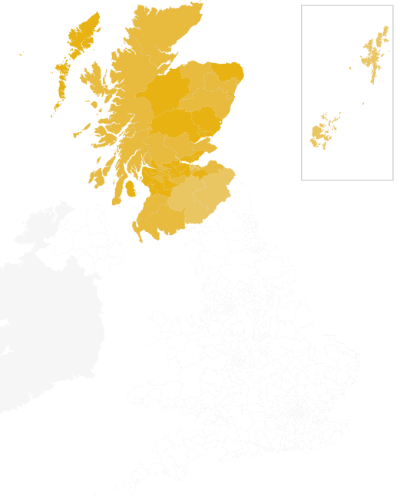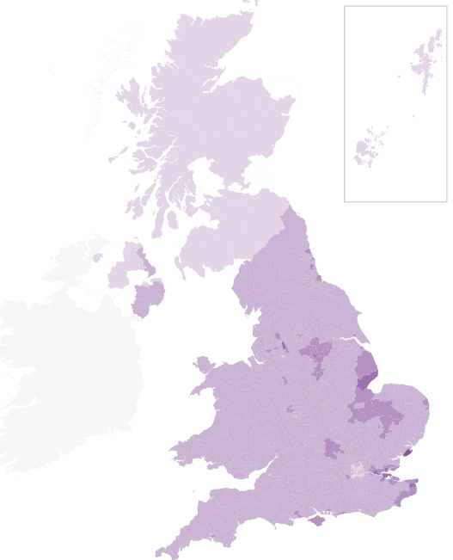

Figure 2 Map showing the spread of SNP votes [2]

Figure Map showing the spread of UKIP votes [2]

Marginal seats are also an occurrence when using a single-winner voting system. Marginal seats are seats for which the leading party has a very small lead over the other popular parties in the associated constituency. Most commonly, these seats are two way marginal, where two parties are in close competition to win. Such seats are an issue because the winning party will have often gained fewer than half of the votes, meaning that most voters in the constituency would prefer for a different candidate to be in power. In some cases, two way marginal seats can develop further into three way marginal seats, which significantly worsens the problem as supporters of the winning party will be considerably outnumbered by the combined supporters of the other two major parties.

Strongly linked to the problem of marginal seats is the issue of tactical voting. This may occur when an elector’s preferred candidate appears to be unable to win the seat, and so voting for their favourite would seem be a waste of the elector’s vote (this particularly occurs in marginal seats). As such, the elector will often choose to vote in such a way as to keep their least preferred candidate out of power.

An example for marginal seats and tactical voting is the constituency of ‘Hampstead and Kilburn’ in London. This was a marginal seat in the 2015 election with Labour winning 44.4% of the votes and the Conservative party winning 42.3% of the votes [4]. In this case, supporters of other parties such as UKIP may have chosen to vote tactically for either Labour or the Conservatives - it would have been clear from opinion polls that their own preference would not win.

A further effect of the lack of representation for voters who do not support the winning candidate, is that voters may be divided if two or more candidates with similar goals run- an occurrence known as ‘split votes’. If this takes place, it can lead to opposition with fewer supporters completely controlling the constituency. The impact of this is most obvious in areas such as Northern Ireland where there is a strong divide between two groups with conflicting ideals. In this case, these groups are the unionists and the nationalists; they are extremely opposed to candidates from the respective opposite groups.

By investigating the results for the constituency of ‘Fermanagh and South Tyrone’ in the 2015 general election, it can be seen that the seat was won by the unionist candidate Tom Elliot, despite him only having 46.4% of the votes, compared to a total 50.8% between the two largest nationalist parties. The reason for this was that –despite outnumbering the unionists- these nationalist voters were split with Michelle Gildernew winning 45.4% of the total votes and John Coyle winning the remaining 5.4% [3]. So, as a consequence of the ‘First Past the Post’ voting system, a constituency that is mostly populated by nationalists is entirely represented in parliament by a unionist.

One advantage to the system is that voters have a strong link to their local MPs, since electors vote for candidates and not for a party. Due to these strong links, voters can be in support of an MP who they believe is good for their area, instead of a particular political party. This was highlighted in 2014 in the constituency of Clacton, when the MP Douglas Carswell defected from the Conservative party to UKIP and resigned his seat. This trigged a by-election but Douglas Carswell was able to win the seat once more (now for UKIP); he had an enormous majority of supporters despite switching parties. [6]

Another anomaly that occurs when using the ‘First Past the Post’ system is that parties can be almost guaranteed to win a certain number of seats in parliament. These seats are known as ‘safe seats’, where an overwhelming majority of supporters of a particular party exist in the associated constituency. In these constituencies, those who do not support the major party in the area will usually have no effect on the overall vote.

In immediate contrast to this however, are situations in which constituencies that are considered as ‘safe seats’ for certain parties are overthrown by other parties. For example, the victories of the Scottish National Party in Scotland in the 2015 election, where they won 56 of the 59 seats [2], a large number of which were considered ‘safe seats’ for the Labour party.

To conclude, it is obvious that the ‘First Past the Post’ voting system has many weaknesses. Despite this, it is very effective at getting results and changing the voting system to a more proportional one would complicate the process, greatly weaken the link between MPs and their constituencies and make coalition governments much more common. It is therefore my belief that the system should remain the way it is – changing the system would present much more of a challenge than continuing to use the current ‘First Past the Post’ system.

# Bibliography

[1] BBC, 2015. *Election 2015 - BBC News.* [Online]   
Available at: http://www.bbc.co.uk/news/election/2015/results  
[Accessed 10 March 2017].

[2] BBC, 2015. *Election 2015: Maps of turnout and party strength - BBC News.* [Online]   
Available at: http://www.bbc.co.uk/news/election-2015-32624405  
[Accessed 10 March 2017].

[3] Wikipedia, 2015. *Fermanagh and South Tyrone (UK Parliament constituency).* [Online]   
Available at: https://en.wikipedia.org/wiki/Fermanagh_and_South_Tyrone_(UK_Parliament_constituency)#Elections  
[Accessed 6 March 2017].

[4] Wikipedia, 2015. *Hampstead and Kilburn (UK Parliament constituency).* [Online]   
Available at: https://en.wikipedia.org/wiki/Hampstead_and_Kilburn_(UK_Parliament_constituency)  
[Accessed 15 March 2017].

[5] Finley, M., 2012. *Discuss the Advantages and Disadvantages of a Coalition Government.* [Online]   
Available at: http://www.peterjepson.com/law/UK-4%20Finley.pdf  
[Accessed 15 March 2017].

[6] Wikipedia, 2014. *Clacton by-election.* [Online]   
Available at: https://en.wikipedia.org/wiki/Clacton_by-election,_2014  
[Accessed 10 March 2017].